Automation_Testing
1. What are the characteristics of a good test case?
1. Should be accurate and tests what it is intended to test.
2. No unnecessary steps should be included in it.
3. It should be reusable.
4. It should be traceable to requirements.
5. It should be compliant to regulations.
6. It should be independent i.e. You should be able to execute it in any order without any dependency on other test cases.
7. It should be simple and clear, any tester should be able to understand it by reading once.
8. Now keeping in mind these characteristics you can write good and effective test cases.
2.How do you write a good test case?
- Use a Strong Title.
- Include a Strong Description.
- Include Assumptions and Preconditions.
- Keep the Test Steps Clear and Concise.
- Include the Expected result.
- Make it Reusable.
- Title: Login Page – Authenticate Successfully on gmail.com.
3. Assume you have a test plan with over 1000 test cases. How would you make sure what should be automated and what should still be done manually?
4.Define a test case and use case? What is the difference?
Use Case | Test Case
Use case describes us the overview of the software functions to reach the final destination. | It demonstrates the test progress and the interaction between the software and the user.
While creating Use case it can combine different case or one case at a time. | As it tests one case at a time so there is no chance of combining the result.
Use case results are not verified. | Test case results are verified, it checks if the result that shows in Use cases is functioning properly or not.

5. What is a test strategy?
A test strategy is an outline that describes the testing approach of the software development cycle. It is created to inform project managers, testers, and developers about some key issues of the testing process. ... They are created based on development design documents.

6. What are the key elements of a test plan and test cases?
1) Objectives
2) scope
3) Approach
4) Testing Methodology
5) Assumption
6) Risk
7) Contigency paln
8) Deliverable
9) Defect Reporting
10) Efforts and Estimation
11) Entry and Exit Criteria
12) Roles and Responsibilities
13) Schedules
14)Testing environment

7. What is the strategy for a successful Test automation plan?
1. Hire a Dedicated Automation Engineer or Team
2. An automation tool is important, but it is not the solution of everything
3. Select the automation tool which is familiar to your resources
4. Know the application being tested
5. Good Automation means good manual test case
6. Identify opportunities with automation
7. You cannot automate everything
8. Avoid GUI Automation when there is an alternate present
9. Use Automation for other useful purposes as well
10. Automation is software development
8. What are the roles and responsibilities of Software Quality Assurance Engineer?
SQA(Software Quality Assurance) Engineer: Job Description, Duties and Requirements. ... Software quality assurance engineers work with software developers to improve software products during development. They run tests on software or applications and analyze defects in order to improve products.

9.What is a bug? What is a bug life Cycle?
A soft bug is an error ,flaw, failure or fault in a computer program or System that causes it to produce an incorrect or unexpected result, or to behave in unintended ways.
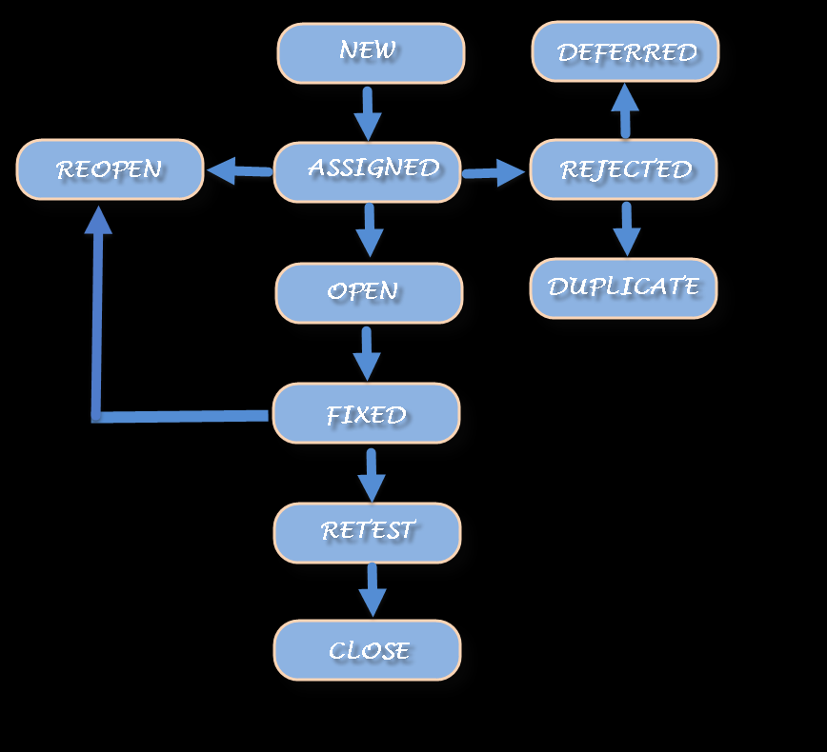

1.What are QA, QC and Software Testing?
They are defined below: Quality Assurance: A set of activities designed to ensure that the development and/or maintenance process is adequate to ensure a system will meet its objectives. Quality Control: A set of activities designed to evaluate a developed work product.
2.What is bug leakage?
Bug leakage is something, when the bug is discovered by the end users or customer, and missed by the testing team to detect, while testing the software.
3.What all things you can automate?
4.What is a framework?
Framework can be defined as a set of guidelines which when followed produce beneficial results.
1) Linear Scripting
2)The Test Library Architecture Framework.
3)The Data-Driven Testing Framework.
4)The Keyword-Driven or Table-Driven Testing Framework.
5)The Hybrid Test Automation Framework.
5.What are the attributes of a good framework?
- Fast
- Modular
- Reusable
- Integrated
- Compatible
6. Can you do without framework?
Yes can we do with out a Framework

